SQL Job Preparation Assignment 1

1. Table DEPT:

-

DEPTNO(PK) DNAME

10 AC

-

Table EMP:



What is the difference between the parent and child tables, and why?

|  |  |  |
| --- | --- | --- |
| -  EMPNO | ENAME | DEPTNO(FK) |
| 101 | ROCK | 10 |
| 102 | JACK | 10 |
| 103 | MARK | 10 |
| 104 | JERRY | 10 |
| - |  |  |

A-The primary key in the parent table acts as a foreign key in the child table and provides the link b/n the two tables.

1. What are the four components of a database management system?

A-Hardware, Software, Data and Users all together form the components of a DBMS.

1. What is the distinction between SQL and SQL plus?

A- SQL is the query language used for communication with SQL server to access and modify the data. SQL* Plus is a command line tool with which you can send SQL queries to the server.

SQL involves **DML**, **DDL** and **DCL, while SQL Plus does not.**

1. What is the definition of normalization?

A- Normalization is the process of organizing data in a database. This includes creating tables and establishing relationships between those tables according to rules designed both to protect the data and to make the database more flexible by eliminating redundancy and inconsistent dependency. There are three types of anomalies that occur when the database is not normalized. These are – Insertion, update and deletion anomaly.

1. Give examples of 1NF, 2NF, 3NF, and BCNF.

A-

1NF (First Normal Form)-

Each table cell should contain a single value.

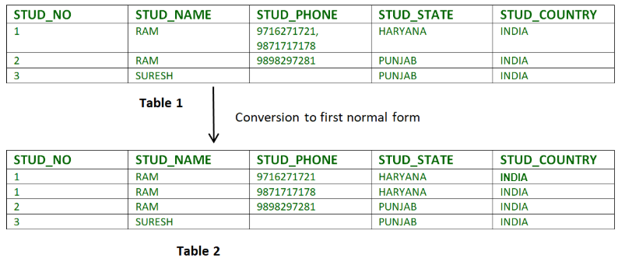

2NF (Second Normal Form)-

Rule 1- Be in 1NF

Rule 2- No non-prime attribute is dependent on the proper subset of any candidate key of table.

|  |  |  |
| --- | --- | --- |
| teacher_id | subject | teacher_age |
| 111 | Maths | 38 |
| 111 | Physics | 38 |
| 222 | Biology | 38 |
| 333 | Physics | 40 |
| 333 | Chemistry | 40 |

**Candidate Keys**: {teacher_id, subject}  
**Non prime attribute**: teacher_age

teacher_details table:

|  |  |
| --- | --- |
| teacher_id | teacher_age |
| 111 | 38 |
| 222 | 38 |
| 333 | 40 |

teacher_subject table:

|  |  |
| --- | --- |
| teacher_id | subject |
| 111 | Maths |
| 111 | Physics |
| 222 | Biology |
| 333 | Physics |
| 333 | Chemistry |

3NF (Third Normal Form)-

Rule 1- Be in 2NF

Rule 2- Has no transitive functional dependencies-changing a non-key column, might cause any of the other non-key columns to change.

Super keys: {emp_id}, {emp_id, emp_name}, {emp_id, emp_name, emp_zip}…so on

Candidate Keys: {emp_id}

Non-prime attributes: all attributes except emp_id are non-prime as they are not part of any candidate keys.

|  |  |  |  |  |  |
| --- | --- | --- | --- | --- | --- |
| emp_id | emp_name | emp_zip | emp_state | emp_city | emp_district |
| 1001 | John | 282005 | UP | Agra | Dayal Bagh |
| 1002 | Ajeet | 222008 | TN | Chennai | M-City |
| 1006 | Lora | 282007 | TN | Chennai | Urrapakkam |
| 1101 | Lilly | 292008 | UK | Pauri | Bhagwan |
| 1201 | Steve | 222999 | MP | Gwalior | Ratan |

employee table:

|  |  |  |
| --- | --- | --- |
| emp_id | emp_name | emp_zip |
| 1001 | John | 282005 |
| 1002 | Ajeet | 222008 |
| 1006 | Lora | 282007 |
| 1101 | Lilly | 292008 |
| 1201 | Steve | 222999 |

employee_zip table:

|  |  |  |  |
| --- | --- | --- | --- |
| emp_zip | emp_state | emp_city | emp_district |
| 282005 | UP | Agra | Dayal Bagh |
| 222008 | TN | Chennai | M-City |
| 282007 | TN | Chennai | Urrapakkam |
| 292008 | UK | Pauri | Bhagwan |
| 222999 | MP | Gwalior | Ratan |

BCNF (Boyce-Codd Normal Form)-

Rule 1- Be in 3NF

Rule 2- Has no more than more than one Candidate Key.

|  |  |  |  |  |
| --- | --- | --- | --- | --- |
| emp_id | emp_nationality | emp_dept | dept_type | dept_no_of_emp |
| 1001 | Austrian | Production and planning | D001 | 200 |
| 1001 | Austrian | stores | D001 | 250 |
| 1002 | American | design and technical support | D134 | 100 |
| 1002 | American | Purchasing department | D134 | 600 |

emp_nationality table:

|  |  |
| --- | --- |
| emp_id | emp_nationality |
| 1001 | Austrian |
| 1002 | American |

emp_dept table:

|  |  |  |
| --- | --- | --- |
| emp_dept | dept_type | dept_no_of_emp |
| Production and planning | D001 | 200 |
| stores | D001 | 250 |
| design and technical support | D134 | 100 |
| Purchasing department | D134 | 600 |

emp_dept_mapping table:

|  |  |
| --- | --- |
| emp_id | emp_dept |
| 1001 | Production and planning |
| 1001 | stores |
| 1002 | design and technical support |
| 1002 | Purchasing department |